# Jenkins task for Day-03.

1. Create one Jenkins job using the below code and create three stages.

stage1: Git clone to download the source code.

stage2: Sonarqube Integration to check the quality of code

stage3: Slack Integration to send the alerts to slack. URL: <https://github.com/betawins/VProfile-1.git>

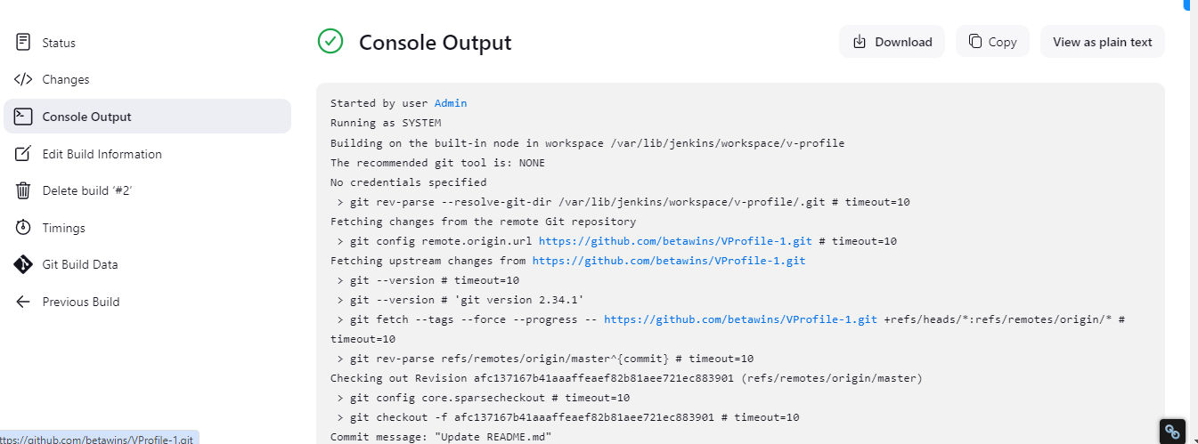

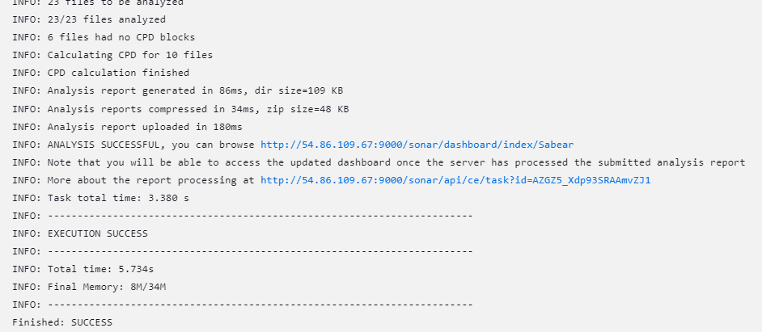

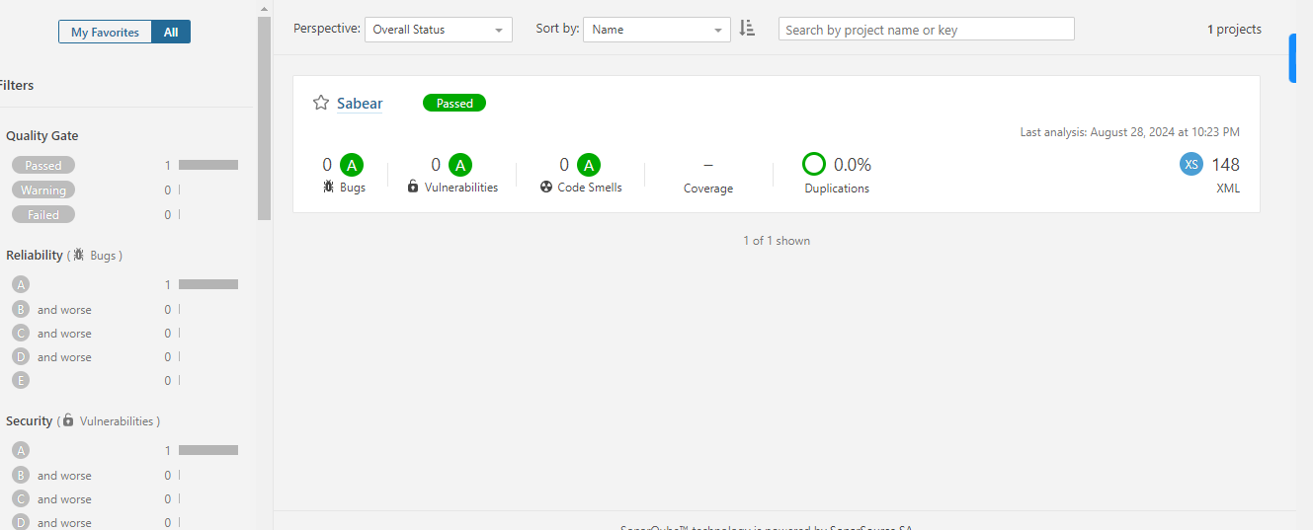

1. Create one Jenkins job using the below code and create three stages.

stage1: Git clone to download the source code.

stage2: Sonarqube Integration to check the quality of code

stage3: Slack Integration to send the alerts to slack. URL: <https://github.com/betawins/hiring-app.git>

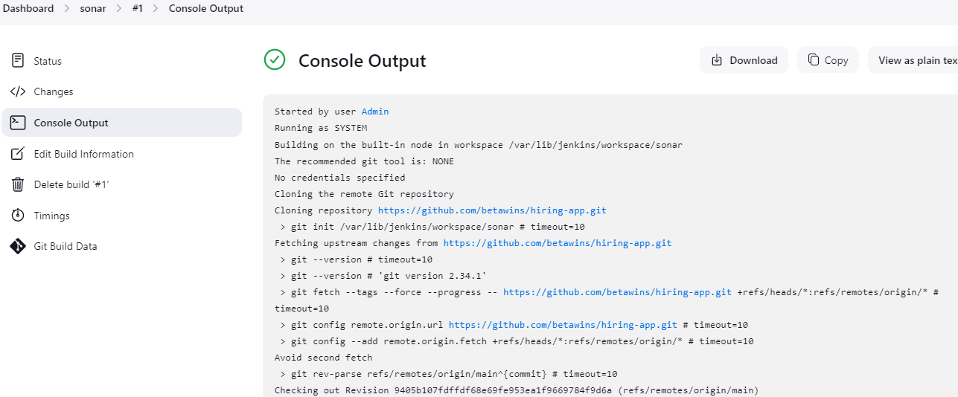

Sonaqube configuration

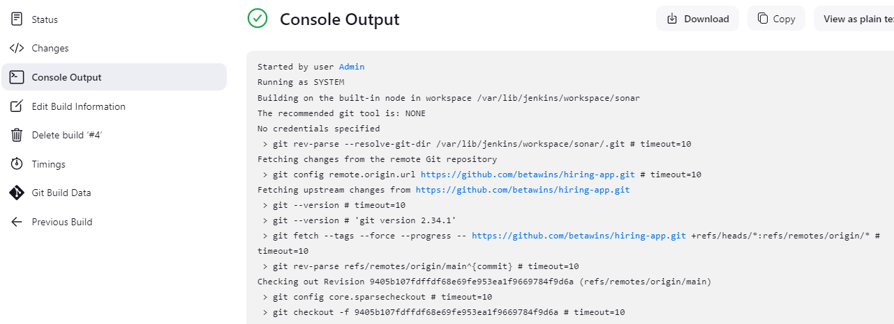

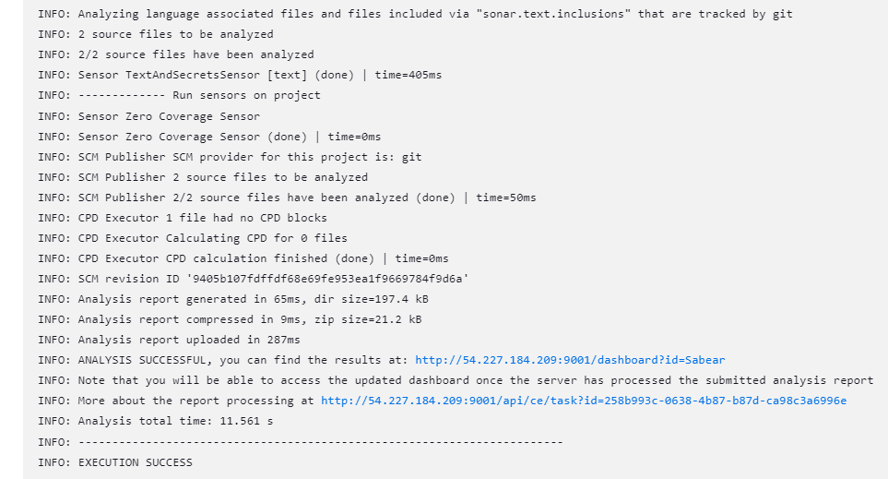

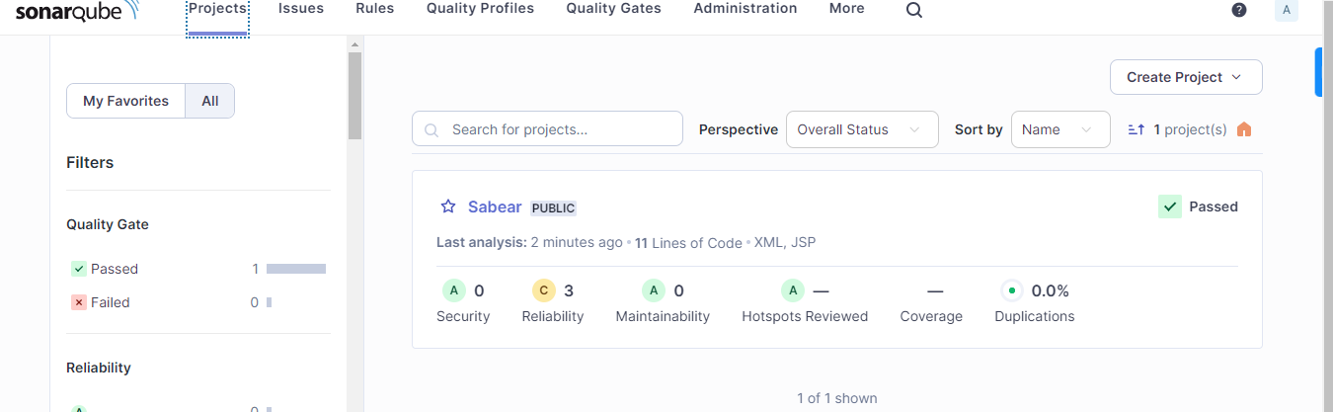

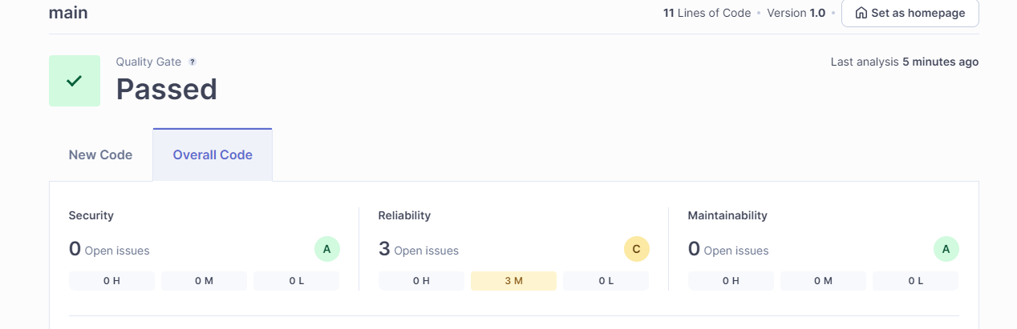

Maven Configuration

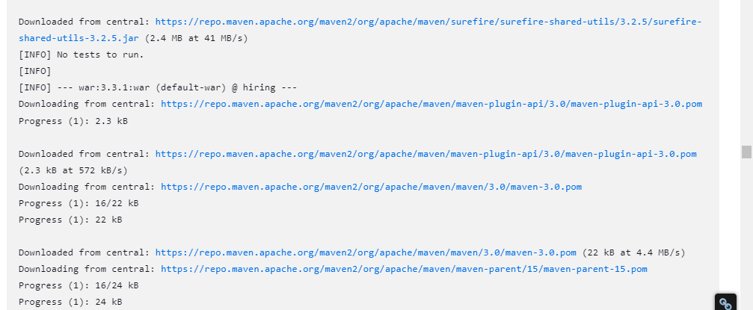

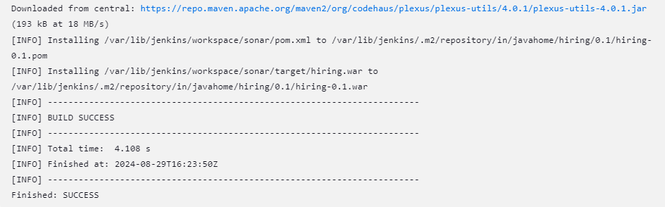

Nexus Installation

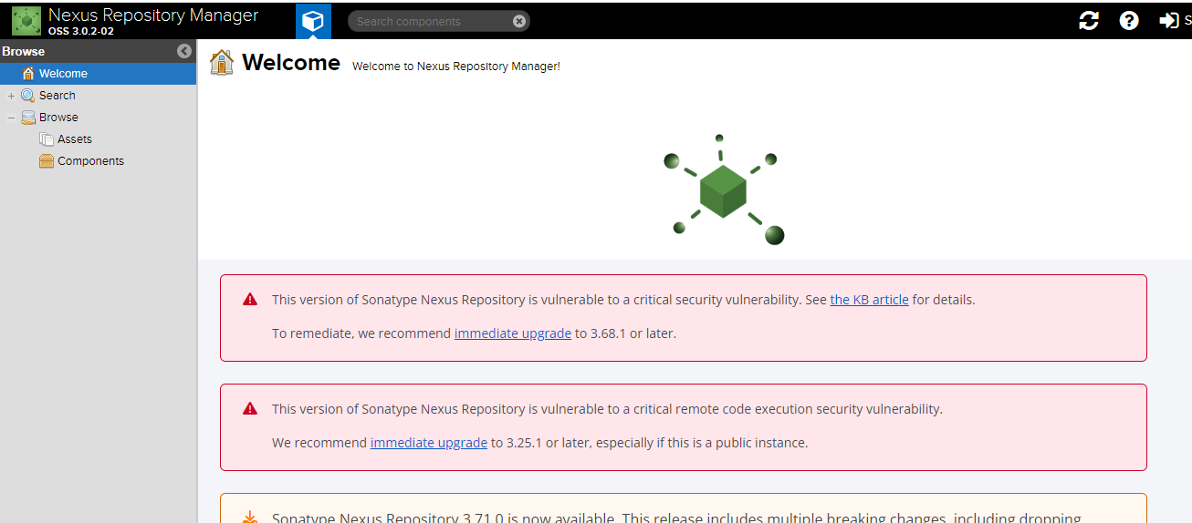

Download Nexus Plugins

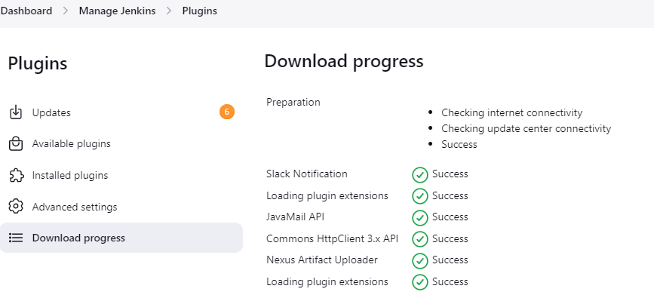

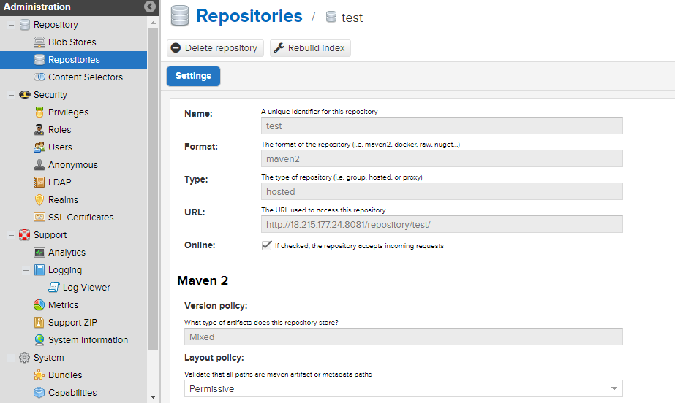

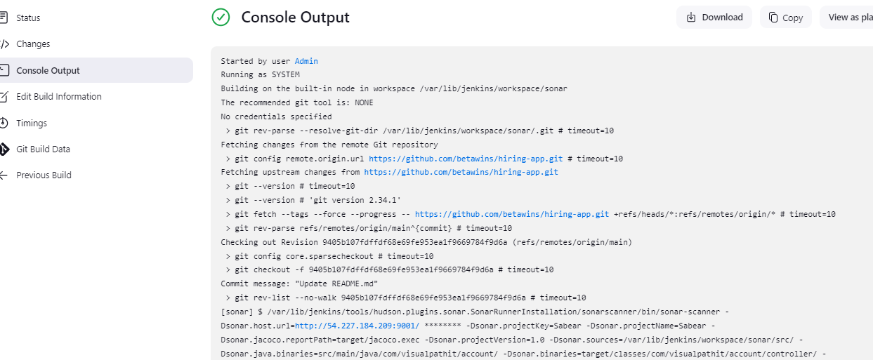

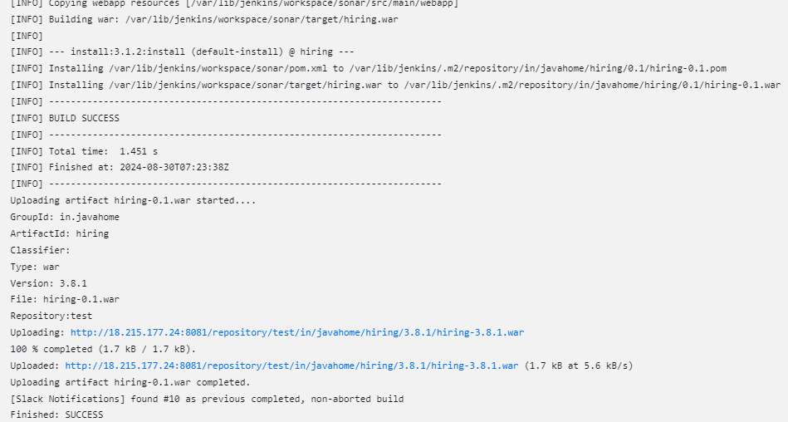

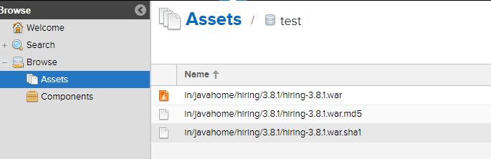

Tomcat Deployment

